**Point System**

Decisions add and subtract from “academic” and “social” points.

**Events**

1. It’s the first day of class. You leave 10 minutes early to get to class but you have no idea where ETB is and are completely lost with only 3 minutes left before class starts.

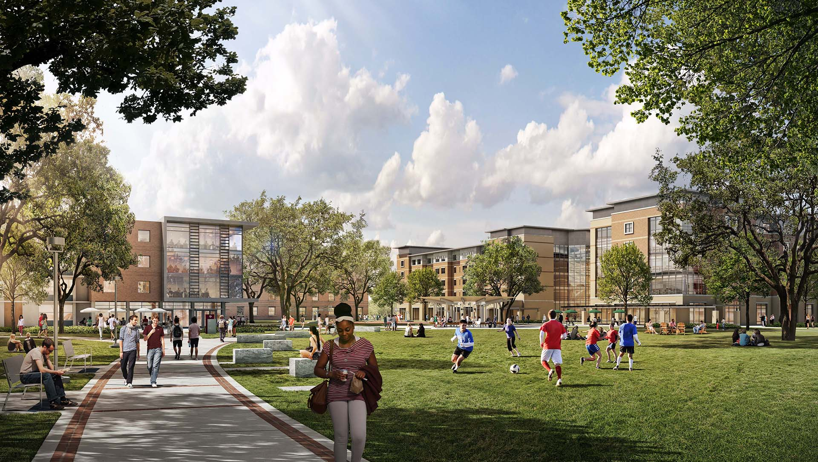

* 1. Ask a stranger for directions
     1. After asking a friendly stranger for directions, you get to class on time and manage to get a seat in the front of the class.
  2. Try to look it up yourself
     1. After wandering around for 10 minutes, you finally get to class and sit in the back of the class.

1. Open house is this week and your friend invites you to go with her. Y’all head out and start talking to a few clubs. You signed up for:

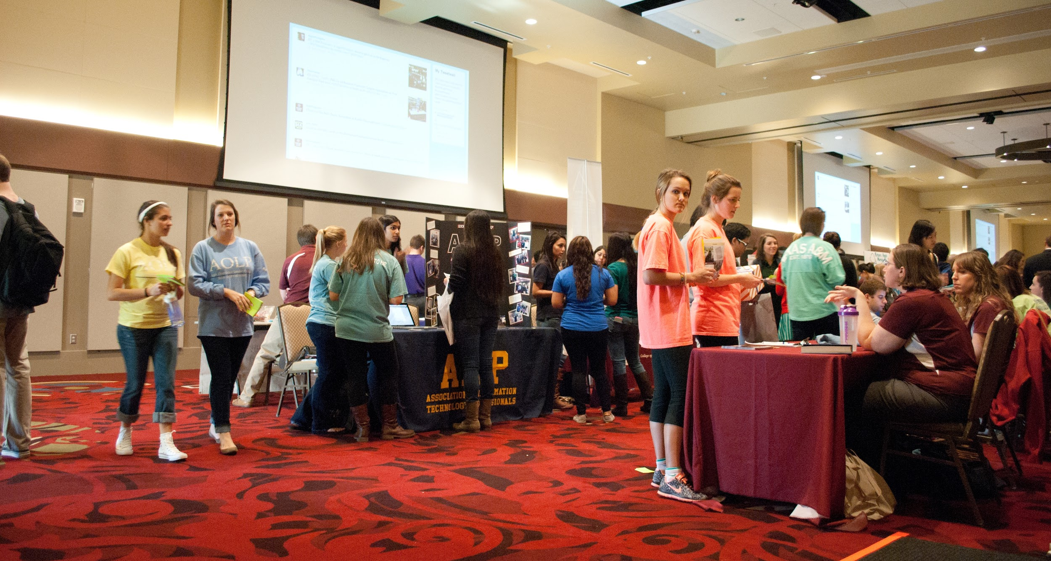

* 1. Academic Club
     1. You have been going to all the club events, from resume fixing to interview practices and even made a few new friends.
  2. Sorority
     1. The sorority immediately invites you out to their event, mixers and sleepovers. You make so many new friends and living your best life.

1. Midterms are a week away; you were invited to study with your classmates at the library. You head to Evans to study. After studying for 2 hours your friends beg you to go grab some food with them.

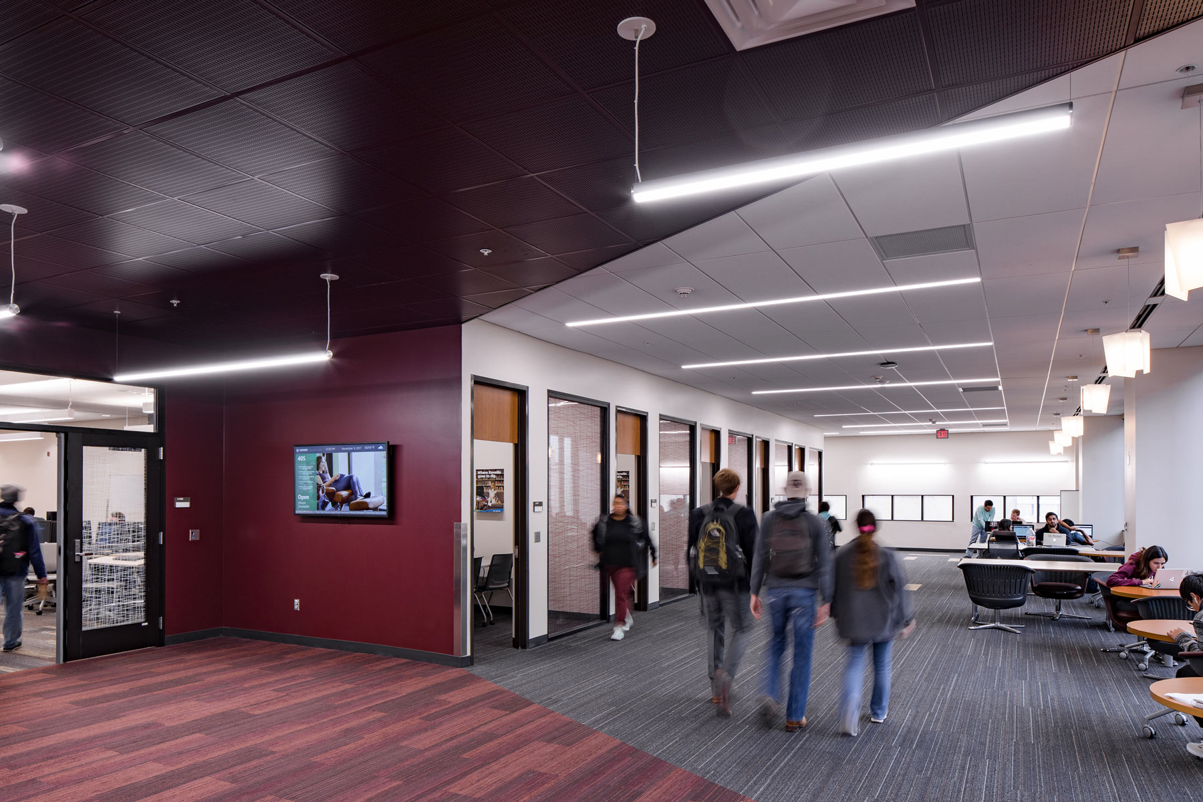

* 1. You and your friends leave to get food together, and study later.
  2. You decide to soldier it out and get some more study time in.

1. After a few weeks, your professor emails out an announcement that midterm grades are out. You quickly pull up ecampus and clicked on grades, to see a 70 staring back at you.

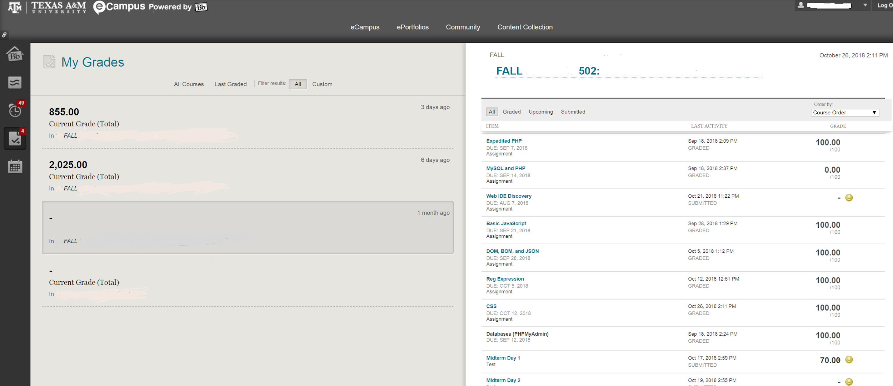

* 1. You breathe a sigh of relief, you can still get a C in this class! C get degrees.
  2. You’re shocked! How could this happen? You studied all week! NO more fun!

1. Beep! Beep! Beep! Your alarm goes off, glancing at the the clock it’s 8:30. You have already missed 30 min of your first class!



* 1. You grab your bag and start running.
  2. Giving it some thought, you would get there for 5 min of class, go home sleepy, and fall back to your warm bed anyway.

1. The week is finally over all your work is turned in, and you’re chilling in your dorm when your received 2 messages from your friends

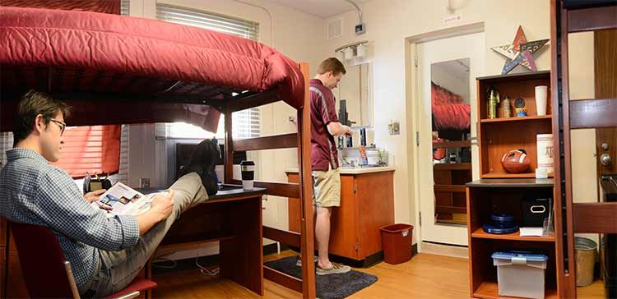

* 1. Hey let’s go study for the finals that’s 3 weeks away!
  2. Hey you worked hard all week wanna go party and celebrate my birthday!

1. Finals week is finally here! You gather all all your study materials and head to the library. You happen to see your classmates at the library and they invite you to study with them.



* 1. You decide to sit with them to study
     1. One topics lead to another and ya’ll ended up chatting the whole time
  2. You study better alone
     1. You studied for a while, but lost steam and fell asleep for 2 hours.

1. It’s the night before your final, it’s already 5am, and your final is at 10am.

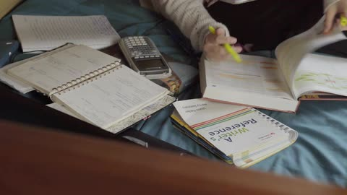

* 1. You should take a nap to get some rest and help you remember things better.
  2. NO push through and keep staring at your textbook

1. After your 4 hour nap, you packed your things and headed to your doom, you feel as if you’ve forgotten everything! Anxiety starts to eat you up inside, you sit down just to start sweating and shaking. The exam starts, you quickly flip through the exam, your head starts to spin, 1987 who, law where? You glance around looking at the clock and the professor, and back down at your paper. … you saw a few answer to your exam.

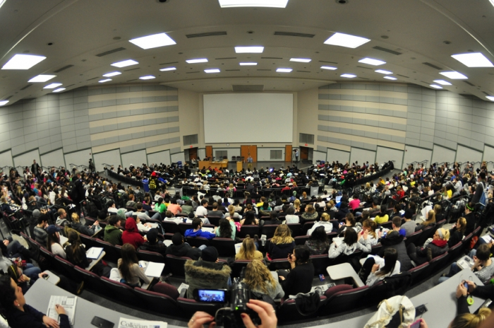

* 1. I mean you think it’s the right answer too so it counts right?
  2. You wave the thought away and continue to scratch your head

1. After returning home for the holiday! The day has finally come! GRADES. You dreaded this day

**Endings/(progress for 1st semester)**

1. Fail/social: You failed most of your classes this semester! You’re put on academic probation and need to do better next semester or you might be suspended from A&M!
2. Fail/unsocial
3. Pass/social
4. Pass/unsocial